**IS6574 Assignment 2**

You are the leader of a small online business that provides government information to many universities in the USA.

Since you have CUI (Controlled Unclassified Information) in your system that you are responsible for, your company needs to follow the NIST 800-171 guidelines.

Your company has a simple website that the clients (university professors) can login to and download CUI from.

Here is a picture of the small business architecture your company uses:

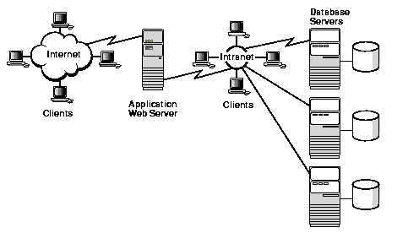

The Internet Clients are the professors who connect to the Web Server. The IntRAnet Clients are employees of the company who work on computers.

The Application Web Server connects to the IntRAnet and can extract information from the many Database Servers (which contain the CUI).

Download the CUI-SSP-Template document from Canvas for Assignment 2. This document is a real SSP for the NIST 800-171 program.

Use the SSP to answer the following questions. Keep your answers to just a few sentences that focus on answering the question succinctly. This is what an auditor would expect to read.

1. For control 3.1.1 what might you implement at your company to satisfy the control?
2. For control 3.1.2 what might you implement at your company to satisfy the control?
3. For control 3.1.4 what might you implement at your company to satisfy the control?
4. For control 3.1.5 what might you implement at your company to satisfy the control?
5. For control 3.1.9 what might you implement at your company to satisfy the control?
6. For control 3.2.2 what might you implement at your company to satisfy the control?
7. For control 3.3.3 what might you implement at your company to satisfy the control?
8. For control 3.5.3 what might you implement at your company to satisfy the control?

When you are finished upload this document into Canvas for your submission.